Set 18: Product Inventory Management

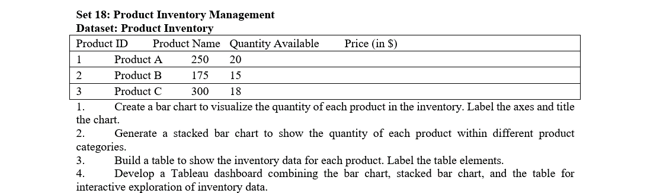

Question 1: Create a bar chart to visualize the quantity of each product in the inventory. Label the axes and title the chart.

Aim:

To create a bar chart in R to visualize the quantity available for each product with appropriate axis labels and a chart title.

Code:

product <- c("Product A", "Product B", "Product C")

quantity <- c(250, 175, 300)

barplot(quantity,

names.arg = product,

col = c("skyblue", "orange", "lightgreen"),

main = "Product Inventory Quantity",

xlab = "Product Name",

ylab = "Quantity Available")

Output:

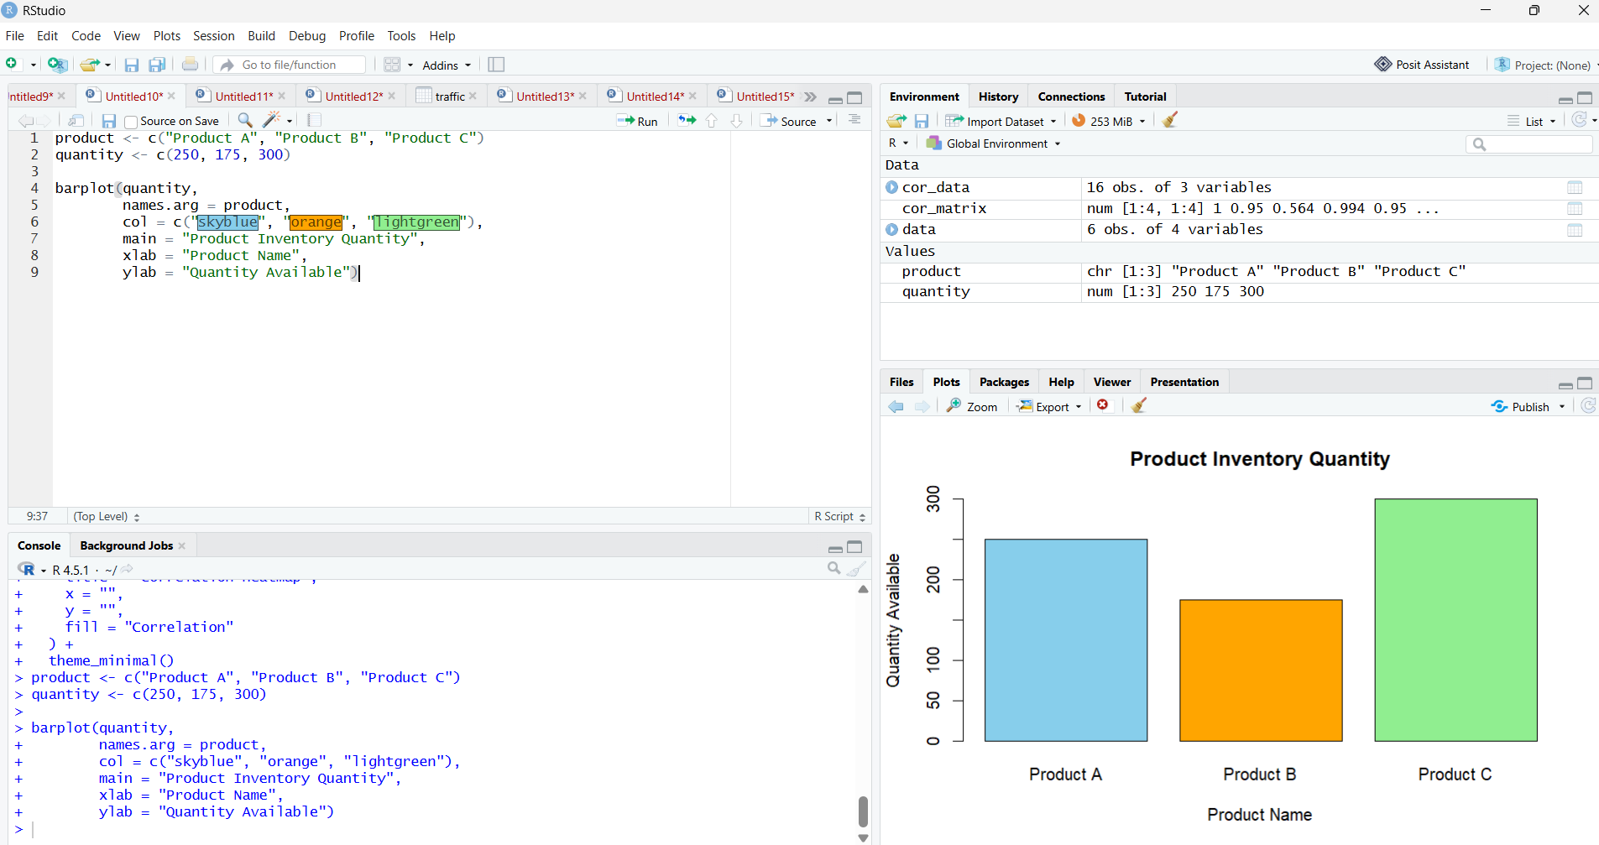

RESULT:
Thus, a bar chart was created successfully to display the quantity available for each product.

Question 2: Generate a stacked bar chart to show the quantity of each product within different product categories.

Aim:
To generate a stacked bar chart in R to visualize the inventory quantities of different products.

Code:

inventory <- matrix(c(250, 175, 300), nrow = 1)

colnames(inventory) <- c("Product A", "Product B", "Product C")

rownames(inventory) <- "Quantity"

barplot(inventory,

col = c("skyblue", "orange", "lightgreen"),

main = "Stacked Bar Chart of Product Inventory",

xlab = "Product",

ylab = "Quantity Available",

legend.text = TRUE)

Output:

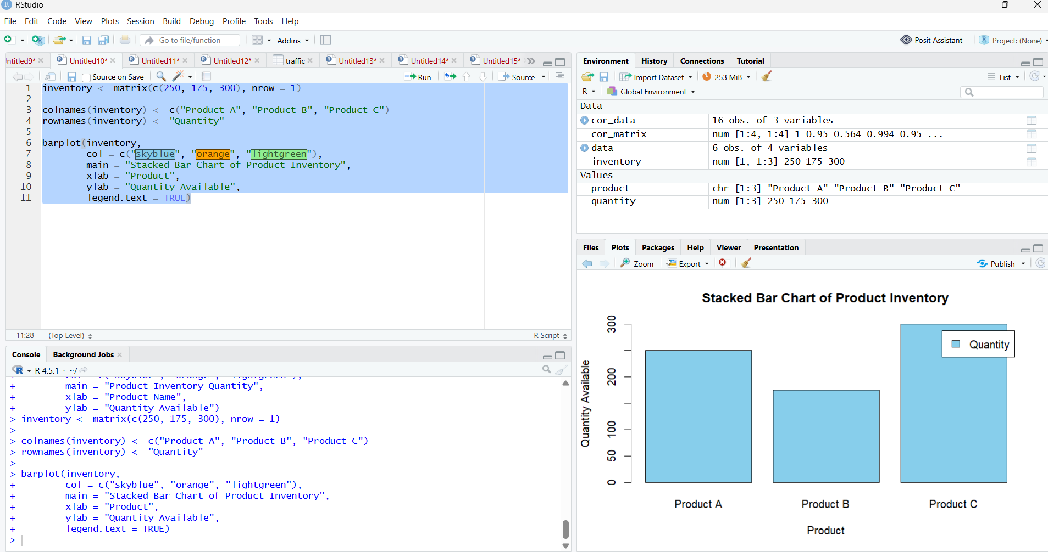

RESULT:
Thus, a stacked bar chart was generated successfully to visualize the inventory quantities of the products.

Question 3: Build a table to show the inventory data for each product. Label the table elements.

Aim:
To create a table in R displaying product ID, product name, quantity available, and price.

Code:

product_id <- c(1, 2, 3)

product_name <- c("Product A", "Product B", "Product C")

quantity <- c(250, 175, 300)

price <- c(20, 15, 18)

inventory <- data.frame(

Product_ID = product_id,

Product_Name = product_name,

Quantity_Available = quantity,

Price_in_Dollars = price

)

print(inventory)

Output:

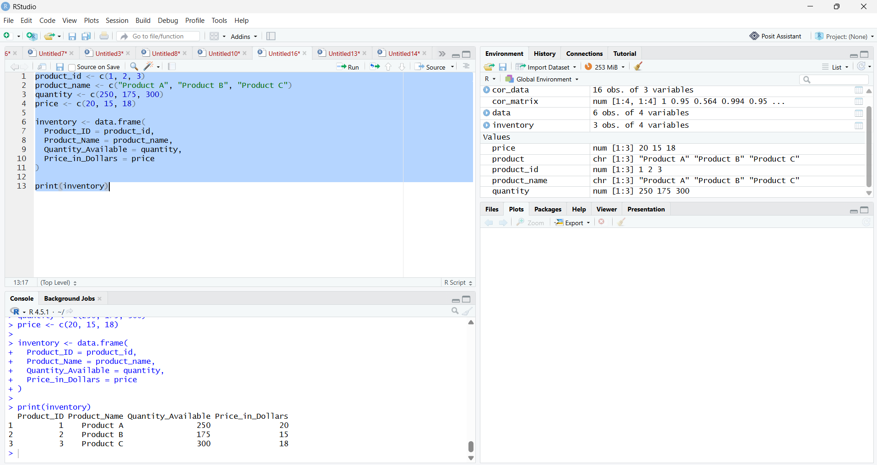

RESULT:
Thus, an inventory table was created successfully with all product details and appropriate column labels.

Question 4: Develop a Tableau dashboard combining the bar chart, stacked bar chart, and the table for interactive exploration of inventory data.

Aim:
To develop an interactive Tableau dashboard combining a bar chart, stacked bar chart, and inventory table for product inventory analysis.
Output:

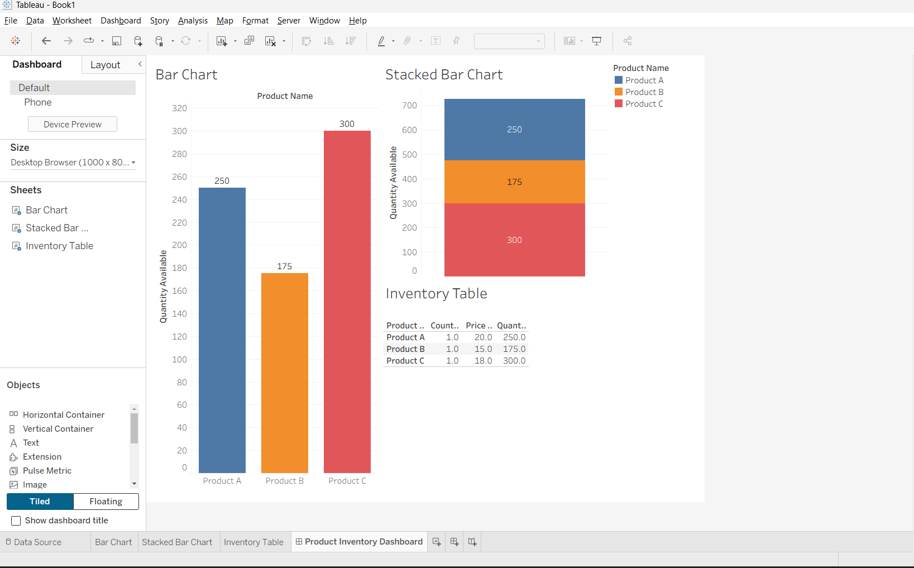

RESULT:
Thus, a Tableau dashboard was created by combining a bar chart, stacked bar chart, and inventory table. Interactive filtering enables users to explore the product inventory data and compare the quantities and prices of different products.

